|  |  |
| --- | --- |
| Roll. No.: A016 | Name: Varun Khadayate |
| Sem/Year: VII/4 | Batch: 1 |
| Date of Experiment: 13/08/2022 | Date of Submission: 13/08/2022 |
| Grade -- |  |

Frequency Reuse Problem

Frequency Reuse is the scheme in which allocation and reuse of channels throughout a coverage region is done. Each cellular base station is allocated a group of radio channels or Frequency sub-bands to be used within a small geographic area known as a cell. The shape of the cell is Hexagonal. The process of selecting and allocating the frequency sub-bands for all of the cellular base station within a system is called Frequency reuse or Frequency Planning.

# Silent Features of using Frequency Reuse:

* Frequency reuse improve the spectral efficiency and signal Quality (QoS).
* Frequency reuse classical scheme proposed for GSM systems offers a protection against interference.
* The number of times a frequency can be reused is depend on the tolerance capacity of the radio channel from the nearby transmitter that is using the same frequencies.
* In Frequency Reuse scheme, total bandwidth is divided into different sub-bands that are used by cells.
* Frequency reuse scheme allow WiMax system operators to reuse the same frequencies at different cell sites.

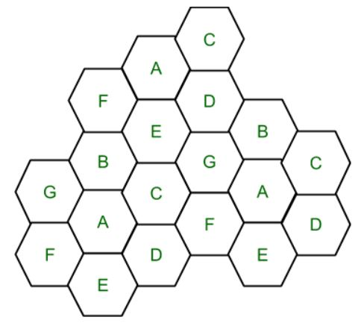

Cell with the same letter uses the same set of channels group or frequencies sub-band.

To find the total number of channels allocated to a cell:

S = Total number of duplex channels available to use  
k = Channels allocated to each cell (k<S)  
N = Total number of cells or Cluster Size

Then Total number of channels (S) will be,

S = kN

Frequency Reuse Factor = 1/N

In the above diagram cluster size is 7 (A,B,C,D,E,F,G) thus frequency reuse factor is 1/7.

N is the number of cells which collectively use the complete set of available frequencies is called a Cluster. The value of N is calculated by the following formula:

N = I2 + I*J + J2

Where I,J = 0,1,2,3…  
Hence, possible values of N are 1,3,4,7,9,12,13,16,19 and so on.

If a Cluster is replicated or repeated M times within the cellular system, then Capacity, C, will be,

C = MkN = MS

In Frequency reuse there are several cells that use the same set of frequencies. These cells are called Co-Channel Cells. These Co-Channel cells results in interference. So to avoid the Interference cells that use the same set of channels or frequencies are separated from one another by a larger distance. The distance between any two Co-Channels can be calculated by the following formula:

D = R * (3 * N)1/2

Where,  
R = Radius of a cell  
N = Number of cells in each cluster

# Code

print("Enter i & j values. common (i,j) values are: (1,0), (1,1), (2,0), (2,1), (3,0), (2,2), (3,3)")

i = int(input("Enter i: "))

j = int(input("Enter j: "))

if i == 0 and j == 0:

    raise ValueError("i & j both cannot be zero")

elif j > i:

    raise ValueError("value of j cannot be greater than i")

else:

    N = (i**2 + i * j + j**2)

    print("N is {}".format(N))

k = int(input("Channels allocated to each cell :: "))

S = k*N

print("Total number of duplex channels available to use:: ",S)

print("Frequency Reuse Factor is :: ",1/N)

M = int(input("Number of repeatations in Cellular System M :: "))

C = M*S

print("Cluster Capacity C is ::",C)

R = int(input("Radius of a cell R :: "))

D = R * (3 * N)**0.5

print("The distance between any two Co-Channels D is :: ",D)

# Output

